Final exam

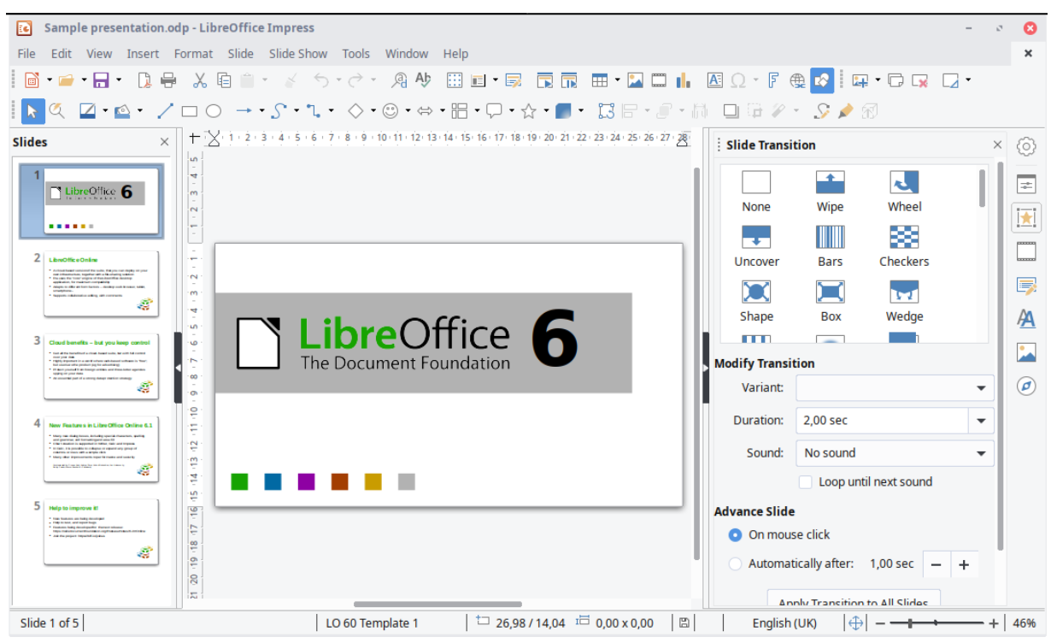

1. Affordance

Affordance refers to a property or feature of an object which presents a prompt on what can be done with this object. E.g. a knob icon give a clue than users can rotate it.

So as we can see in the left, there is a dark blue background of the current slide, therefore, users can know which is the current slide available for edit

1. Mapping is a design principle

The scroll bar can provide mapping in LibreOffice interface. It tells users where (which slides means which part of the whole ppt)he or she is in the whole slide. When there are many slides, it is easy for users to map, locate.

Users can use the scroll bar to up and down to choose which part of the slide he or she wants to edit.

1. Two heuristics of your choosing
2. Match between system and real world

The icon of operation like save is a disc, cut is a scissors; print is a printer, etc. They are real item in the real world.

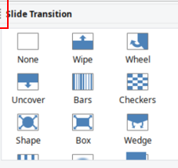

And the image of effect in the slide transition is also real in the real word.

1. Recognition rather than recall

The operation(saving/cut/print etc.) and effect of slide are all listed in the interface. So it is provide “recognition” for users to select. It is better than recall, users may have no idea what does he should do if just use recall.

* How do these two heuristics link into cognitive load theory

Linking heuristics/ design principle to cognitive load theory is very useful to improve the design. It works because ultimately they reduce the load on our limited working memories. In this way it is easier to process and make sense of information.

1. Two cognitive load effects of your choosing

The Split Attention Effect occurs when users have to refer to two different sources of information simultaneously when learning something. This creates an extra load on their brain as switching between tasks takes time, effort and energy.

Actually in the interface, there are too many things to select, they are in different area, but they are still very close. Most of them are in the form of text with image. All of these issue result in Split Attention Effect .

expertise reversal effect refers to instructional techniques that are highly effective with inexperienced learners. And instructional techniques may has less effectiveness or even lose their effectiveness and negative consequences with more experienced learners.

From my point of view, I haven’t see any shortcut path in this interface, there are many edit we can do for a slides, so the experienced user may feel tired repeat the action again and again, which result in less effectiveness in experienced users.

1. Two examples of visual design of your choosing

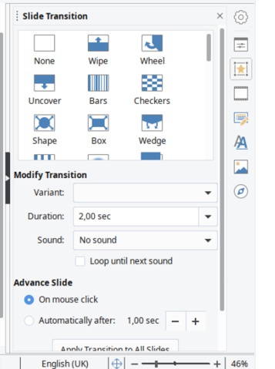

Item is in chunk and grid , around different effect, there are enough space around each one too, so it is visible for users to choose.

(icon of editing and operation) is Match between system and real world, and it is also visible, the heuristic can improve visible design.

1. An annotated sketch of how any issues you found can be improved (you will be able to upload a file to attach to this answer).

In this part too many operation is in the same area



I will use chunk to separate them, easy for users to recognize , more visible, enough space between each chunk

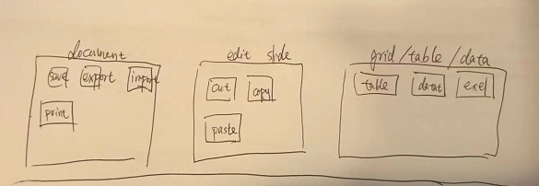

1. 题目：

Diagrams can help to reduce the load on working memory because they：



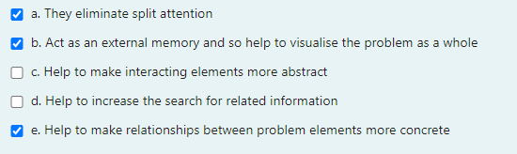diagram减少abastract



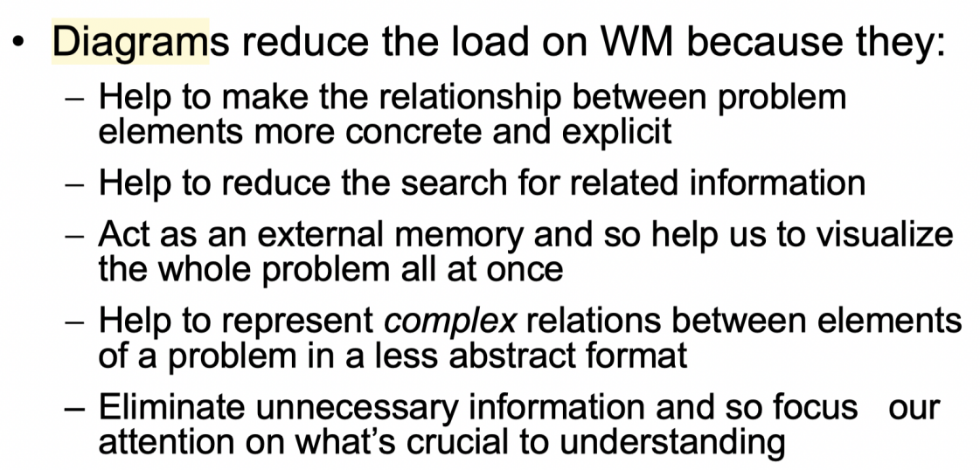



Which of the following is/are NOT the purpose of a ‘dry run’ in usability testing?



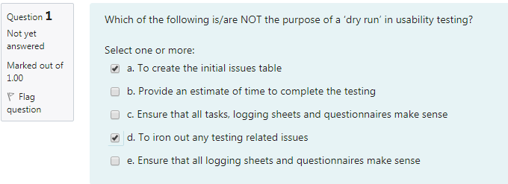not所以选✖的 resolve/fix



The Gestalt principles of perceptual organisation include:

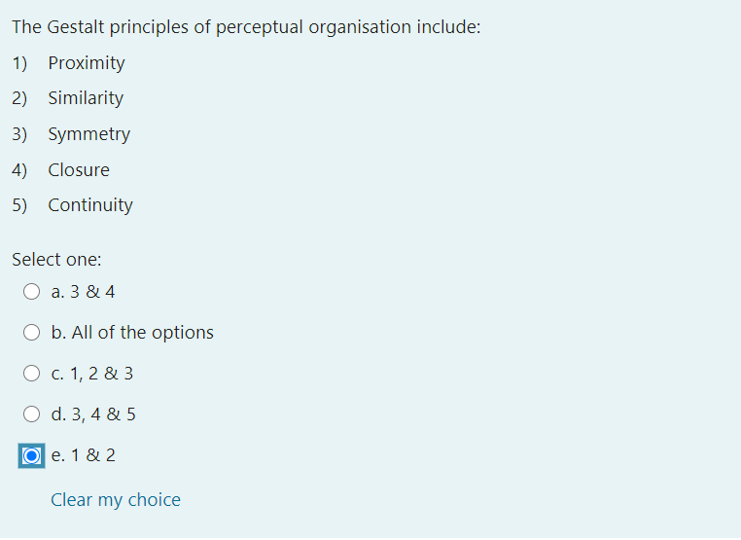



Which of the following is/are NOT the purpose of an issues table:



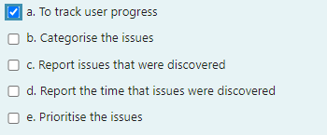



1. 题目

# One of important considerations when designing an interface is to provide ways for users to easily escape from places they unexpectedly find themselves, by having clearly marked emergency exits. This is an example of which heuristic principle?

**Design Principles**

• Visibility

• Feedback

• Constraints

• Mapping

• Affordance

**Heuristics**

• Visibility of system status

• Match between system and real world

• User Control and Freedom

• Consistency & standards

• Help & documentation

• Help users recognize, diagnose, and recover from errors

• Error prevention

• Recognition rather than recall

• Flexibility and efficiency of use

• Aesthetic and minimalistic design

**UX Goals** 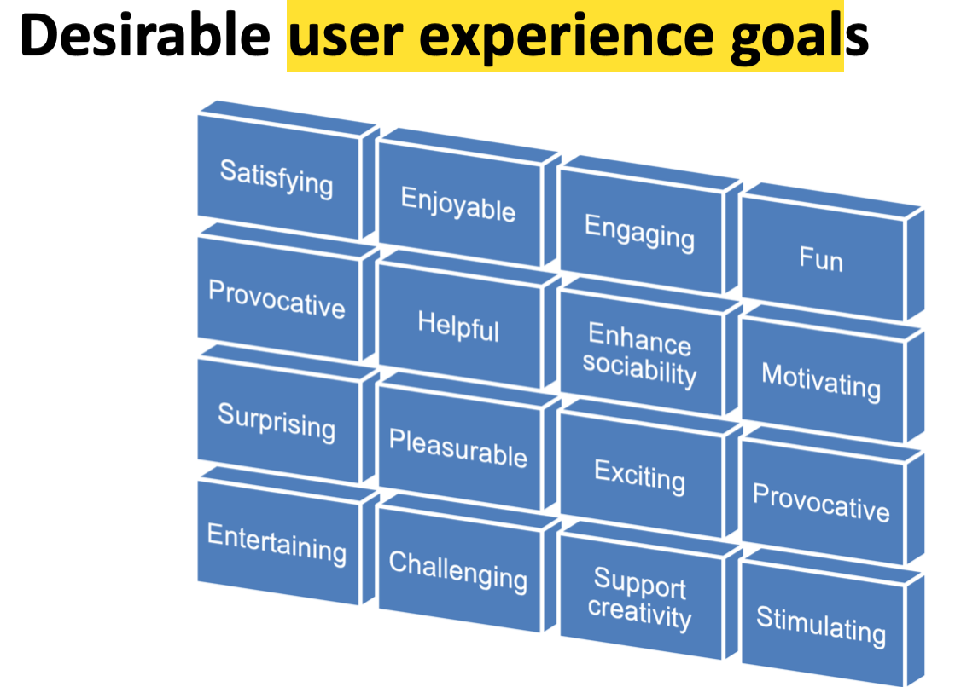

• Satisfying

• Enjoyable

• Helpful

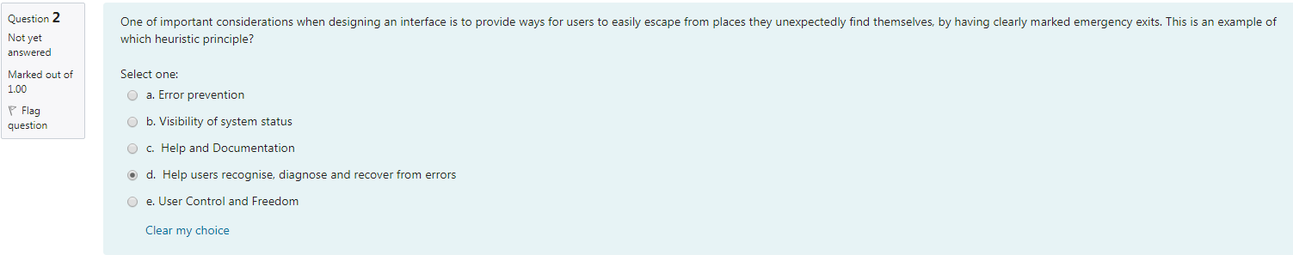



When you group a mobile phone number in groups of 4, 3 and 3 digits, as opposed to a whole 10-digit number, this is an example of:

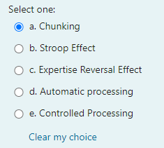

Which of the following statements describing brainstorming is TRUE?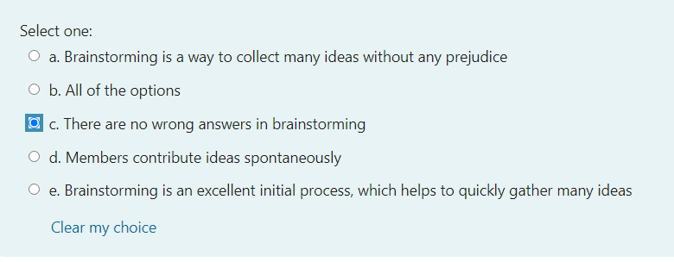



**Usability Goals**

• Effective - effective to use

• Efficient - efficient to use

_______________ is a Usability Goal, referring to how easy a system is to use on subsequent uses:

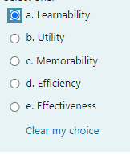

• Safe to use - safety

• Utility - provides good utility

• Learnability - easy to learn

• Memorability - easy to remember how to use

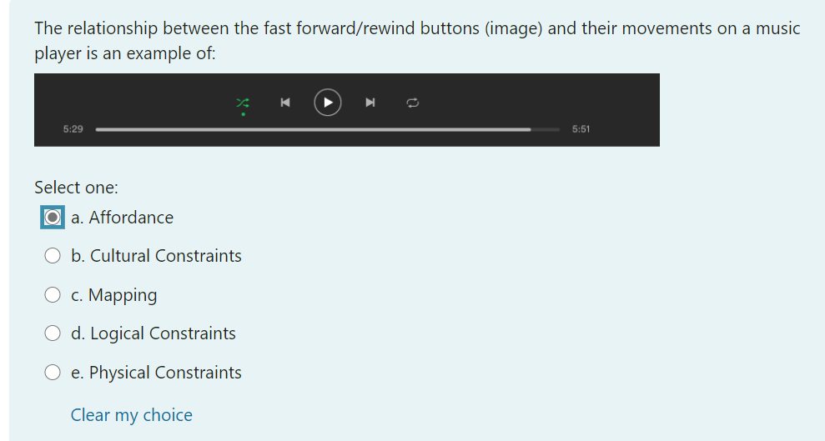



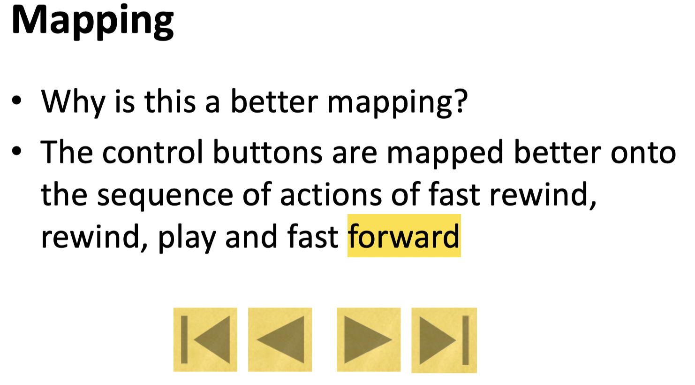

1. 题目：

Providing keyboard shortcuts addresses

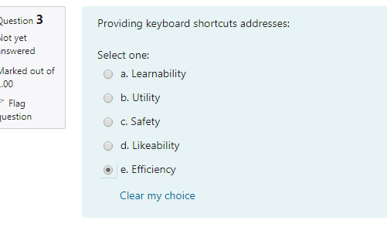



**Usability Goals**

• Effective - effective to use

• Efficient - efficient to use

• Safe to use - safety

• Utility - provides good utility

• Learnability - easy to learn

• Memorability - easy to remember how to use

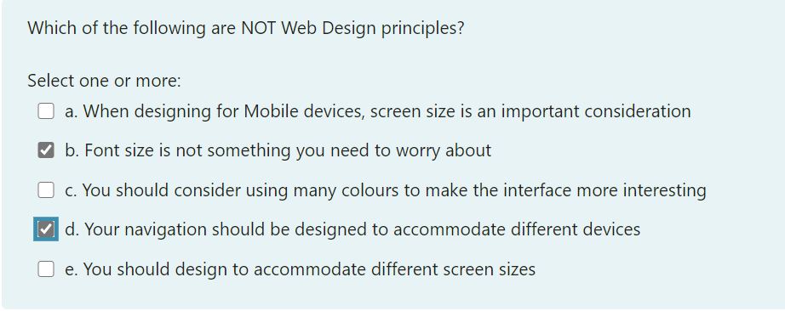



**Design Principles**

• Visibility

• Feedback

• Constraints

• Mapping

• Affordance

Colour as a perceptual tool

• Powerful way of dividing display into separate

regions

• Useful for search tasks

– spotting an object in a list, but of less usefor

tasks requiring categorisation or memorisation

*– too many colours will increase search times*

• More effective with inexperienced users

‘Brian is 17 years old and works part time at the museum gift shop in the Sydney CBD. There are currently 5 employees working at the gift shop at any one time, and they are all about the same age as Brian. Brian has worked at the gift shop for the last two years and is very comfortable in the requirements of his job, including using the till daily in a variety of different ways.’

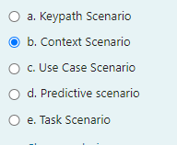



1. 题目：

When does an interface ~~need~~ to be evaluated?

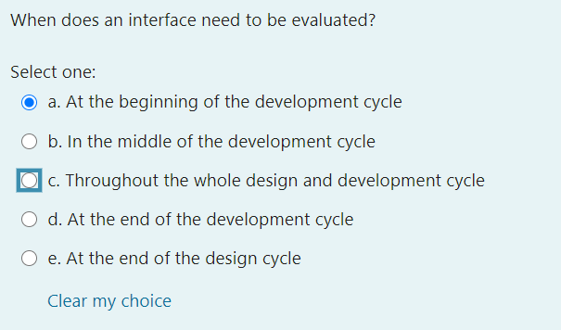



Which answer(s) is/are CORRECT about the difference between Fitts Law and Keystroke Level Model?

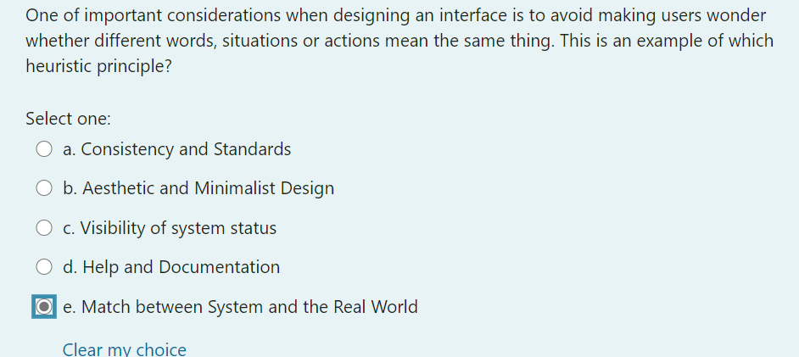



One of important considerations when designing an interface is to provide ways for users to easily escape from places they unexpectedly find themselves, by having clearly marked emergency exits. This is an example of which heuristic principle? User control

1. 题目：

What are the benefits of testing at an early stage (low fidelity prototype/ paper prototype)?

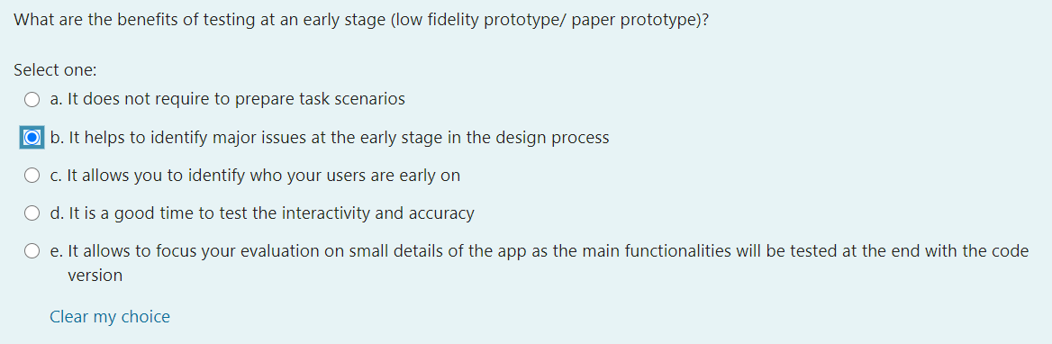



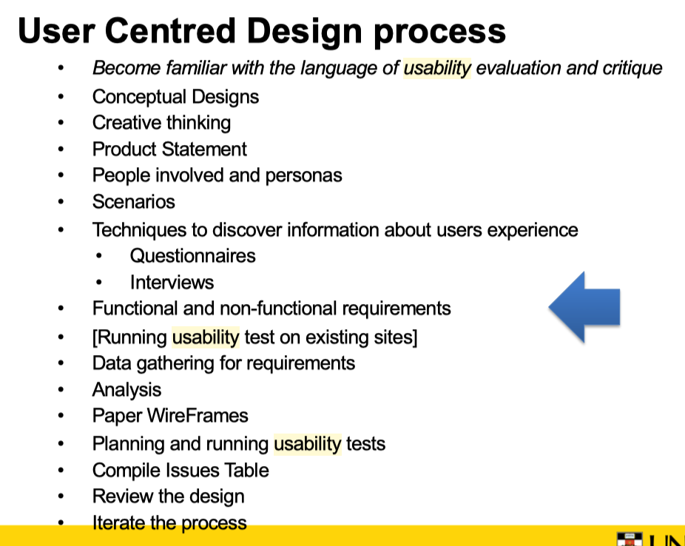

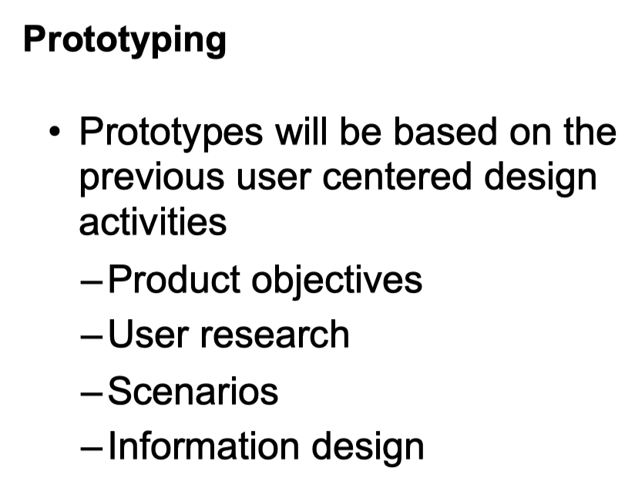



The relationship between tasks and goals is:

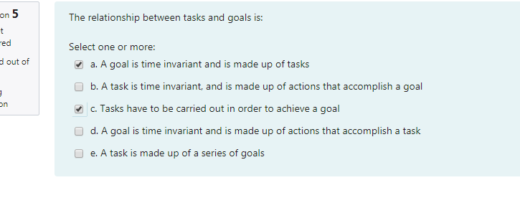



Automated schemas have two functions: (where WM = Working Memory, and LTM= Long Term Memory)

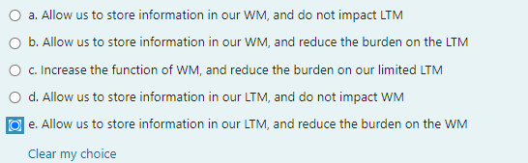



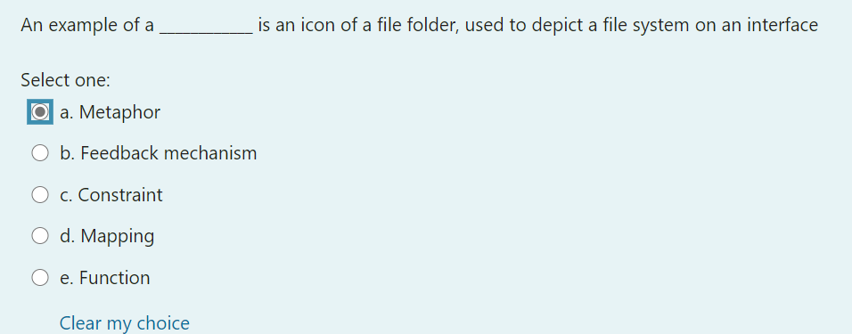



Which of the following statements is/are TRUE?

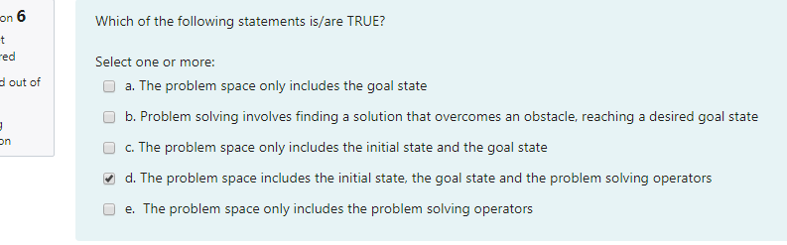



An issues table is an important tool because it:

Choosing what data gathering technique to use does NOT depend on？——————

The approach you take to understand user

needs will depend on whether you are creating

a new product, enhancing an existing one,

rethinking a existing one

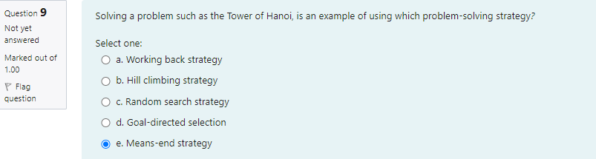

**手段--目的analysis：**

**是指将需要达到的问题的目标状态分成若干子目标，通过实现一系列的子目标最终达到总目标。**

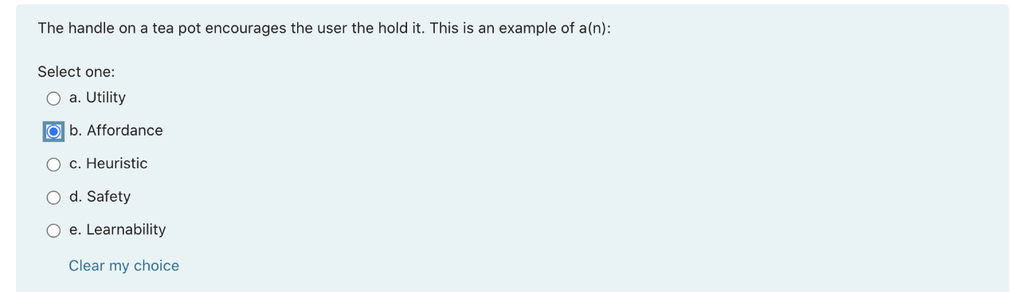

|  |  |
| --- | --- |
| **请以此格式上传**  **题干复制方式：**  **F12**  **ctrl+F 搜索题干关键字**  **复制题干**  **截图回答**  Which of the following are Usability goals? | **Usability Goals**  • Effective - effective to use  • Efficient - efficient to use  • Safe to use - safety  • Utility - provides good utility  • Learnability - easy to learn  • Memorability - easy to remember how to use |
| Which answer(s) is/are CORRECT about the difference between Fitts Law and Keystroke Level Model? |  |
| Not correct |  |
| Providing keyboard shortcuts addresses: |  |
| when does an interface need to be evaluated? |  |
| What are the benefits of testing at an early stage (low fidelity prototype/ paper prototype)? |  |
| When you group a mobile phone number in groups of 4, 3 and 3 digits, as opposed to a whole 10-digit number, this is an example of: |  |
| What are some ways in which expert/novice differences can be taken into account? |  |
| The Gestalt principles of perceptual organisation include: You are an avid user of social media, and in particular, |  |
| You are an avid 热衷的user of social media, and in particular, Facebook. When you are using Facebook, you are an example of a/an: |  |
| Which of the following is/are examples of a user experience goal?  **UX Goals**    • Satisfying  • Enjoyable  • Helpful |  |
| The excessive use of animations could be detrimental to learning. This is an example of: | transient information effect |
|  |  |
| **不是flash的，所以不需要只放7个**  **相似的要靠近** | **Menus** **Grouping** |
| Which of the following is/are NOT a measurable human factor in evaluating a specific interface? | Usibility goal  • Usability goals should be measurable,   objective, and concrete |
| Which of the following is INCORRECT? It is important to test interfaces to ensure: | 我们要reduce search |
| which is correct?  revolutionary革命性的  evolutionary进化的 | Different stages of design require different levels of complexity, difficulty, and fidelity. |
|  | • Evolutionary Prototyping–  Each prototype is a real piece of the final   product |
|  |  |
|  |  |
| Online game |  |
|  | - Collaborative computing provides an environment in which   people can collaborate on a common task without time/space   constraints.  - Social computing refers to any computing technology that   supports social interactions, connecting people together,   facilitating collaborations & potentially predict social   outcomes.  - Same time, same place (video-games, classroom tech.) |
|  |  |
| Referring how easy the system is |  |
|  |  |
| Voice recognition===wechat语音转文字 |  |
| Which of these statements is/are CORRECT? analogy | • Novices users of a system have little prior   knowledge or schemas in the area and so tend to   use means-ends-analysis (a trail and error type   strategy) to navigate their way around. **They**  **need lots of meaningful cues and feedback.** |
| Modality(方法) effect  Split att |  |
|  |  |
| Dry run |  |

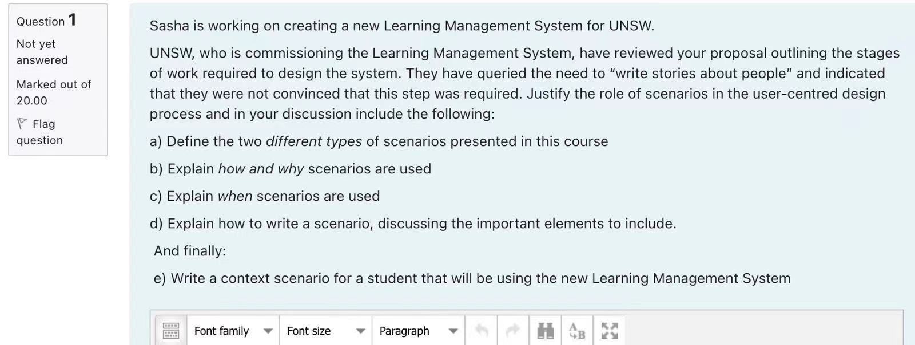

a）

Context scenario

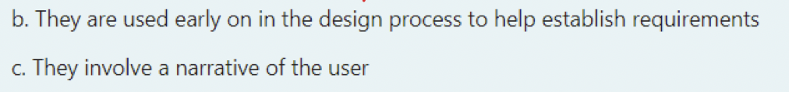



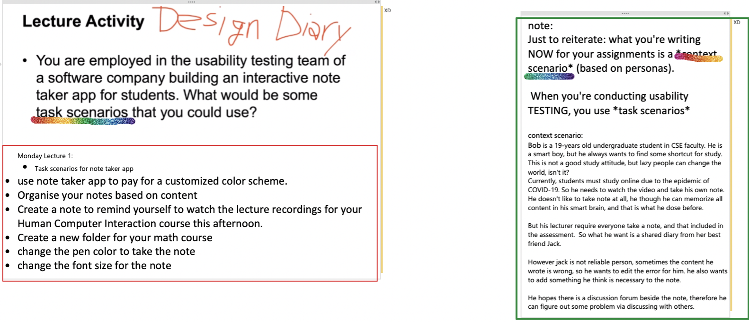

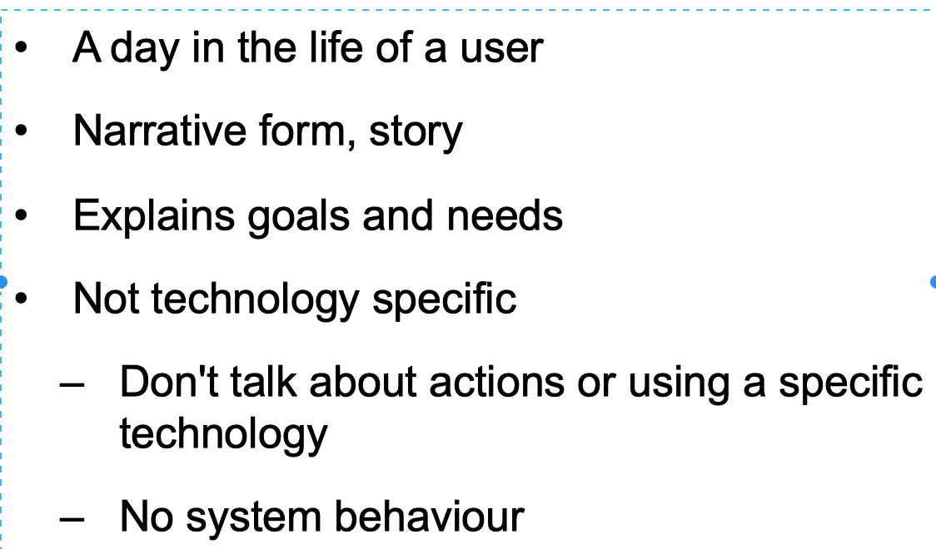

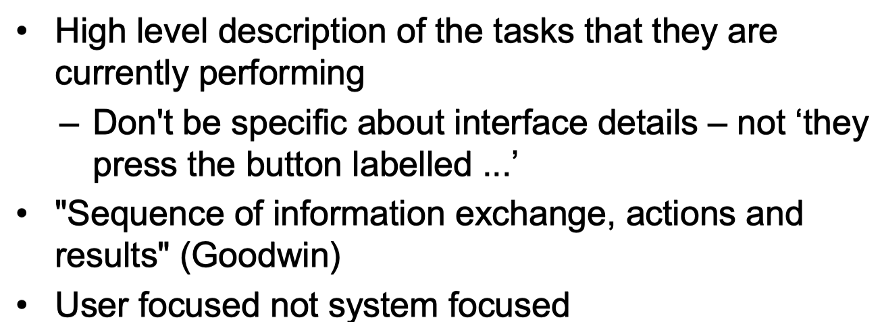

"Context scenarios should be compelling: they need to engage the imagination and help people see the possibilities, not bog them down in detail"

Sasha is flying to Melbourne and needs to catch a taxi to her hotel on her arrival. She decided to withdraw some money from the ATM. When she gets to the ATM, she withdraws one hundred dollars. She decides that she wants this money in $20 notes, so that it is easier to pay for things without needing as much change. She doesn’t want a printed receipt, as the random pieces of paper just usually collect at the bottom of her bag.

Sasha has just realised that she has no ingredients to make dinner tonight. She grabs her keys, and some bags and runs out to her car to get to the shops before they close. Once she gets to the shops, she parks her car, and grabs a trolley. She wanders through the shop picking up items that she may need for dinner. However, she realises that she has forgotten her shopping list at home, so she quickly calls her partner to look up the list and tell her what she needs to purchase. She hastily gets to the checkout and realises that she has also forgotten her rewards card for the supermarket. The line at the checkout is huge and she has to wait a long time. She wishes that she could pay as she goes for her shopping, so she wouldn’t constantly have to be waiting at the checkout. She finally gets to the front of the line and pays for her groceries.

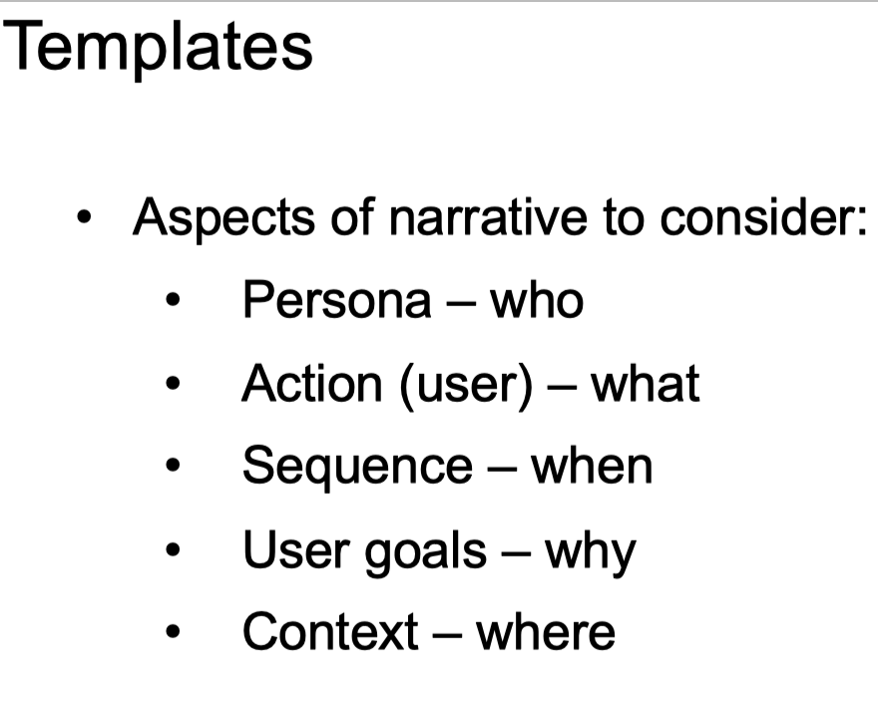

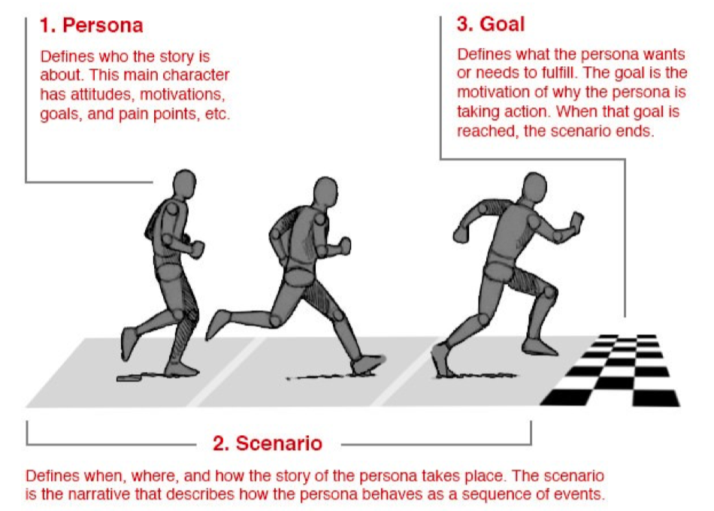

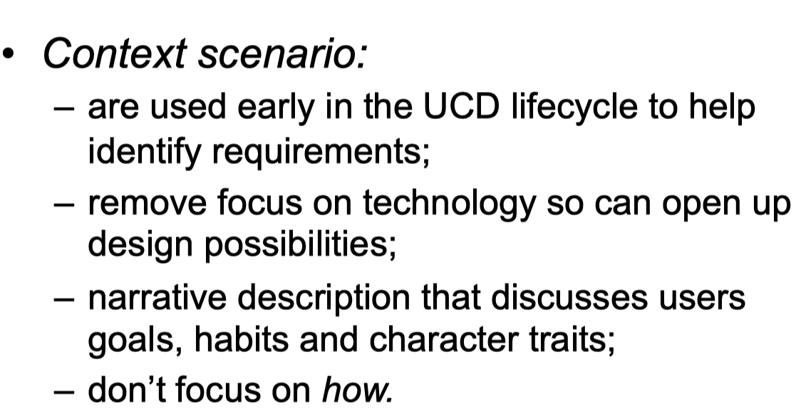

Task scenario

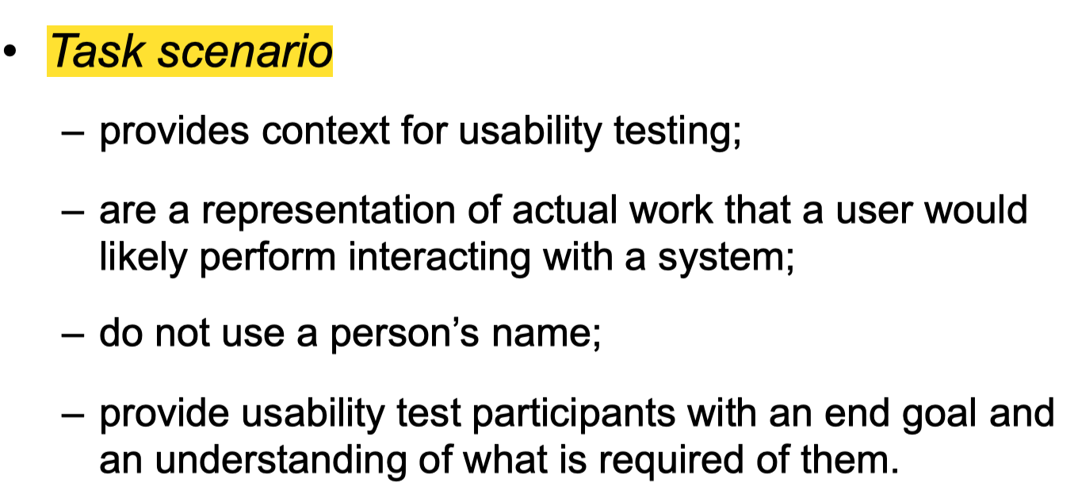

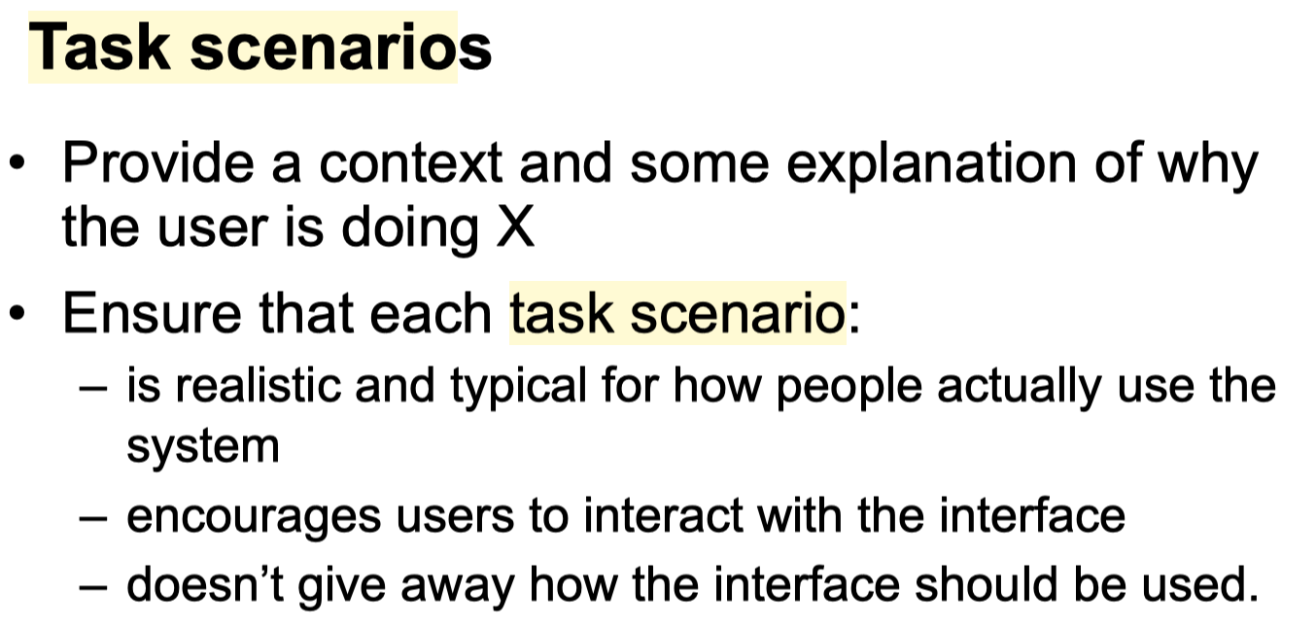

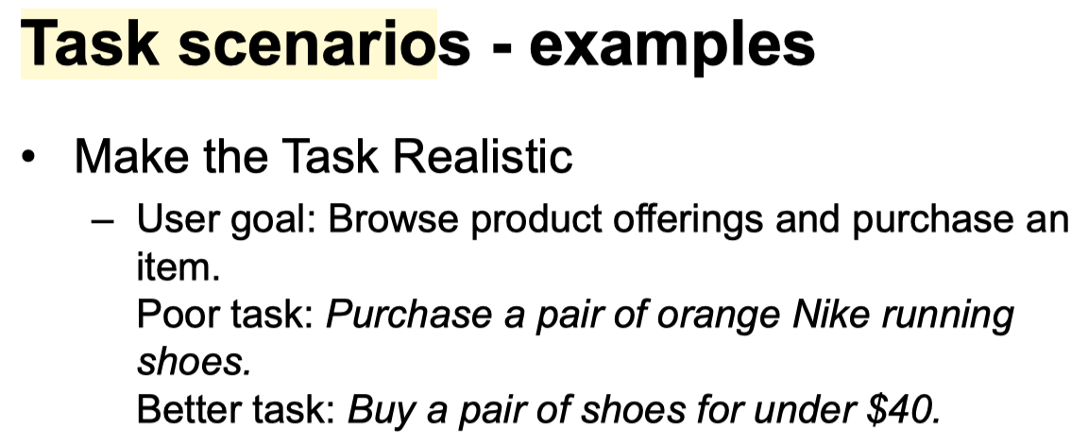

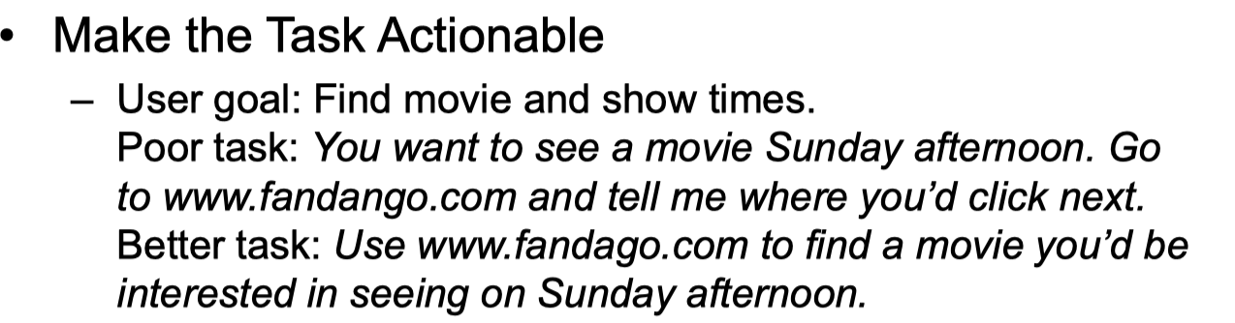

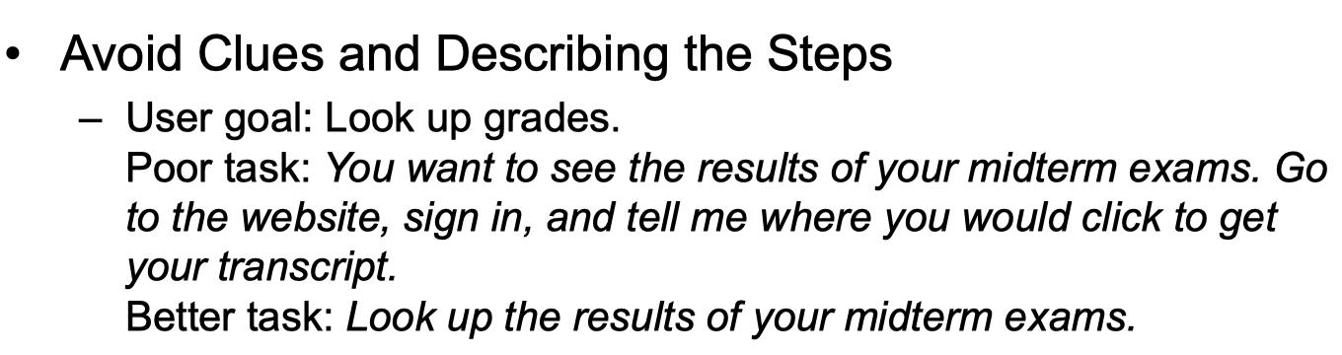

Mark is a 25-years old postgraduate student in CSE faculty. He is from Italy. He is a hardworking and studious student, but now he is under big stress of both finance and study. His WAM is 89 now. He hopes to apply for a PhD in the future, but it is not easy for him to maintain and improve his WAM.

Currently, students must study online due to the epidemic of COVID-19. However, sometimes Mark cannot understand what the lecturer is saying in the video because English is not his mother tongue. Therefore, he prefers to spend his spare time watching the recording repeatedly. He finds the new functions on the the new learning management system system is helpful for his study.

Due to his poor financial condition, He is doing a part-time job to afford his rent in Sydney. So, he wants to set a quicker speed of the lecture recording to save the study time. He uses the function of speed changing on the new learning management system to study more efficiently. As an international student, he also suffers from poor English listening. Therefore, sometimes he was unable to get the lecturer’s point well like his local colleague. For this aspect, Mark can use the caption function to resolve.

Another difficulty is that sometimes his lecturer, who comes from India has a strong accent, so he hopes there are two captions for the recording, one is his mother tongue and another one is English. These functions on the new learning management system really make Mark improve his study efficiency. Now, He has confidence in maintaining and improving his WAM and then apply for a PhD in the future.

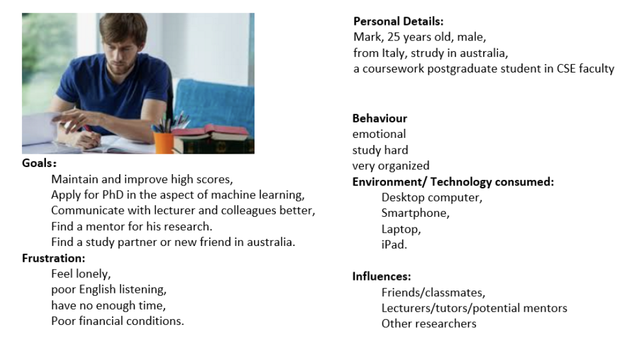

Q2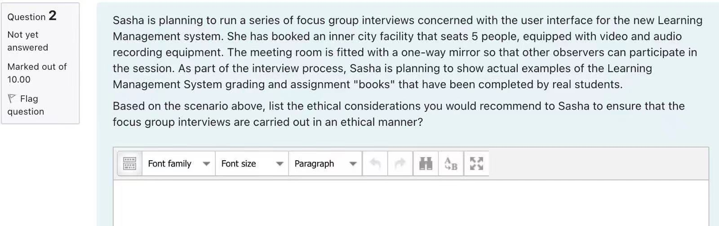

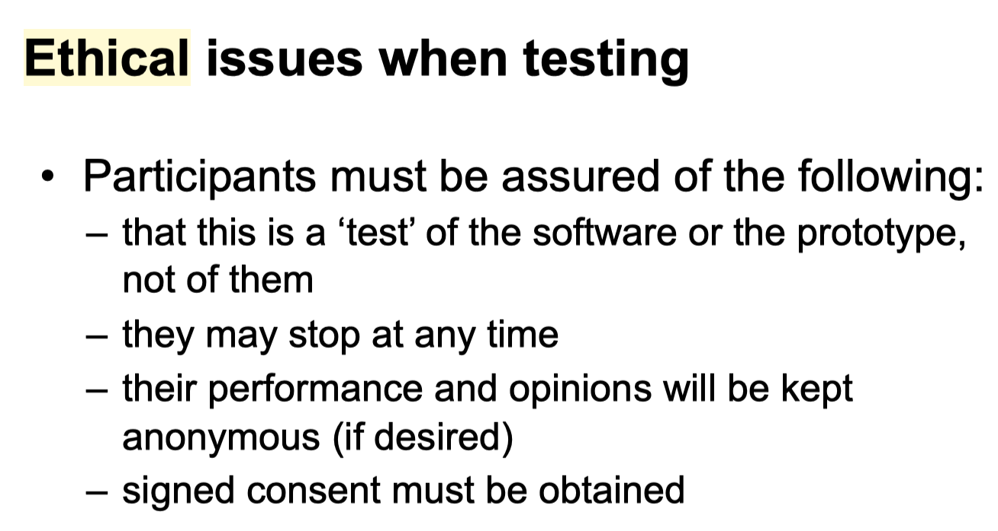

During user feedback session

• Ensure that the participant understands the purpose of the session and understands exactly what kind of observation and recording is taking place

• Ensure that the participant does not feel uncomfortable (either physically or mentally)

• Ensure that you do not pass judgement on the participant's performance or opinions

Privacy, observers & recording of data

Assure them that the information and opinions they provide will be used only for research purposes.

e.g. Representatives from the companies involved in the research will be observing the session [eg from behind the one-way mirror/via CCTV].

Example data use

• The data recorded may be used for:

– Analysis, to review interactions after the session

– Documenting the findings of the session

– Providing feedback to the project team about the design and how well it does/does not meet peoples` needs or communicating the same to other stakeholders within the organisation sponsoring the research

– Teaching or training purposes by [researcher] or [client] but only for demonstrating the process of a typical research session

Consent Form

• Before a study/interview have the participant sign a consent form giving his/her permission for you to observe and/or record their comments and performance

• Ensure that the participant's identity remains confidential

• Allow the participant to terminate the session at any time

Assure them that the information and opinions they provide will be used only for research purposes.

e.g. Representatives from the companies involved in the research will be observing the session [eg from behind the one-way mirror/via CCTV].

The data recorded may be used for:

– Analysis, to review interactions after the session

– Documenting the findings of the session

– Providing feedback to the project team about the design and how well it does/does not meet peoples` needs or communicating the same to other stakeholders within the organisation sponsoring the research

– Teaching or training purposes by [researcher] or [client] but only for demonstrating the process of a typical research session

Before

• Plan the interview or session in advance and develop a written protocol (agenda) of what will be achieved in the session

• Consider the duration of the session

• Prepare consent documentation

• Prepare any other documentation (background, prototypes, questionnaires)

• Find participants

During

• Welcome the participant

• Make them feel comfortable

• Give an introduction to the purpose of the session

• Provide an opportunity to ask questions

• Provide and complete the consent form (2 copies)

After

• Provide an opportunity for them to ask questions

• Ensure they have a copy of the consent forms

• Thank them for their time

Q3

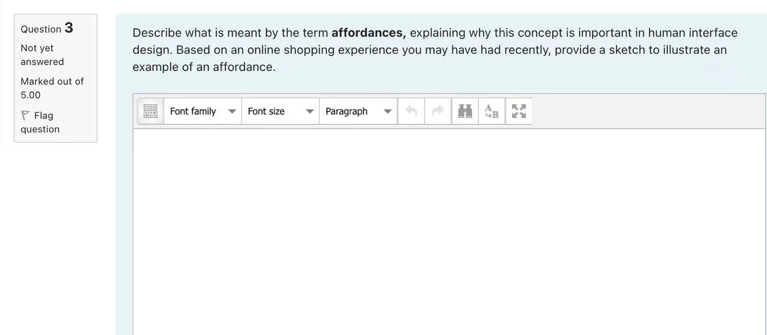

Affordances

• "the perceived and actual properties of the thing, primarily those fundamental properties that determine just how the thing could possibly be used"，**• "affordances give strong clues to the operations of things"，Refers to an attribute of an object that allows people to know how to use it**

**What does ‘affordance’ have to offer interaction design?对hci对重要性**

• Interfaces are virtual and do not have affordances like physical objects

• Norman argues it does not make sense to talk about interfaces in terms of ‘real’ affordances

• Instead interfaces are better conceptualised as ‘perceived’ affordances

– Learned conventions of arbitrary mappings between action and effect at the interface

– Some mappings are better than others

Eg：scrollbars to afford moving up and down, icons to afford clicking on。

a mouse button invites pushing, a door handle affords pulling。

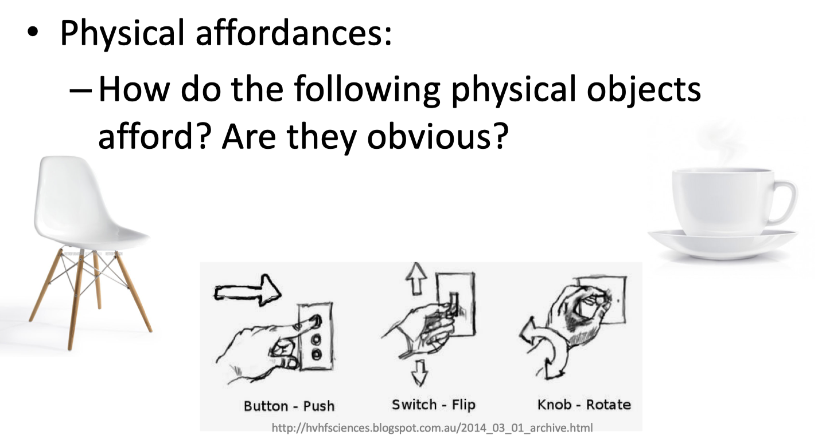

给online、shopping的drag sth into cart

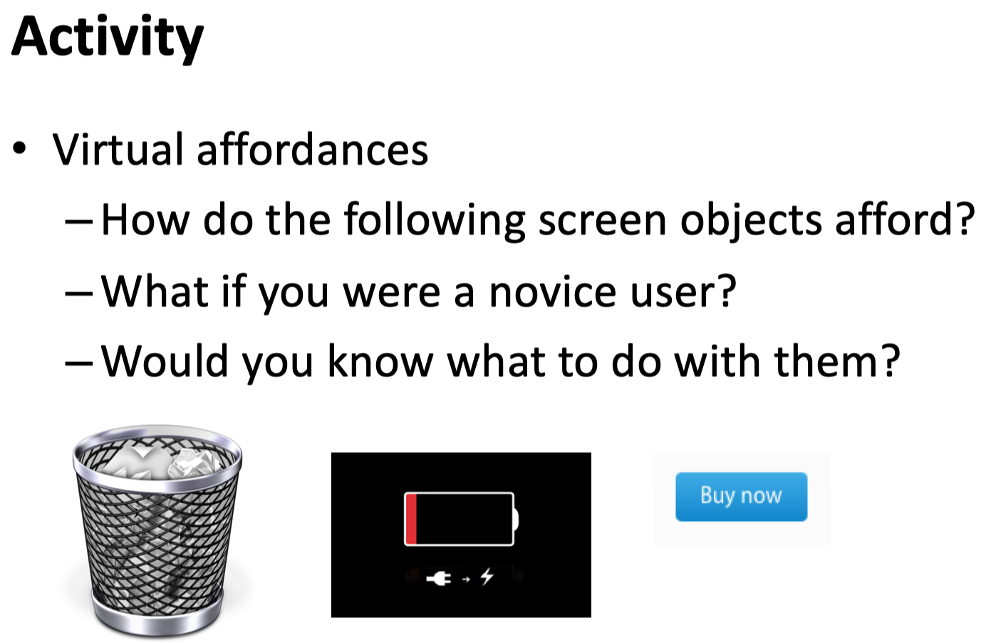



Q4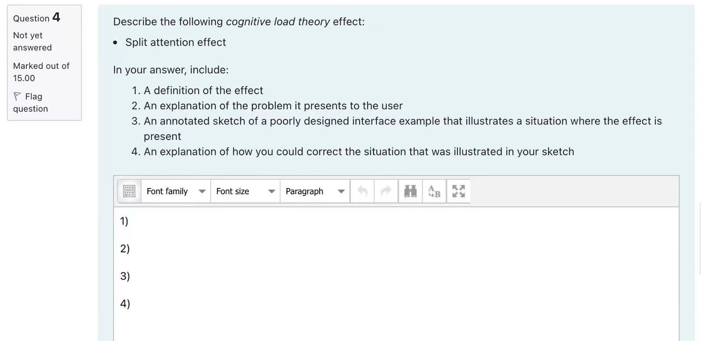

The Split Attention Effect occurs when students have to refer to two different sources of information **simultaneously** when learning something. This creates an extra load on their brain as switching between tasks takes time, effort and energy.

When information is structured such that it requires people to mentally integrate information that is physically split, this imposes an unnecessary burden on our limited WM.

• Mutually referring sources of information should be physically integrated. This reduces the strain on our limited WM and frees up cognitive capacity for other processing.

**Applications of the Split Attention effect**

• Text referring to a diagram should, when possible, be integrated into the diagram.

• Related text should be contained on the same screen or page.

• Interfaces should not force users to recall information from one screen, that they need to type into another screen.

• Integrated training packages that do not split users attention between the screen and the manual, should be used.

• Web navigation should not force users to split attention between where they are and where the want to be, by forcing users to look at many unnecessary pages of information.

